COMPLETE GUIDELINE TO INSERT EXCEL DATA INTO DATABASE.

1. Install excel library

>> composer require maatwebsite/excel

You might face an error like this:

To enable extensions, verify that they are enabled in your .ini files:

- C:\Users\user\Downloads\php-7.3.8-nts-Win32-VC15-x64\php.ini

You can also run `php --ini` inside terminal to see which files are used

by PHP in CLI mode.

[Solution: Go to C:\xampp\php\php.ini file]

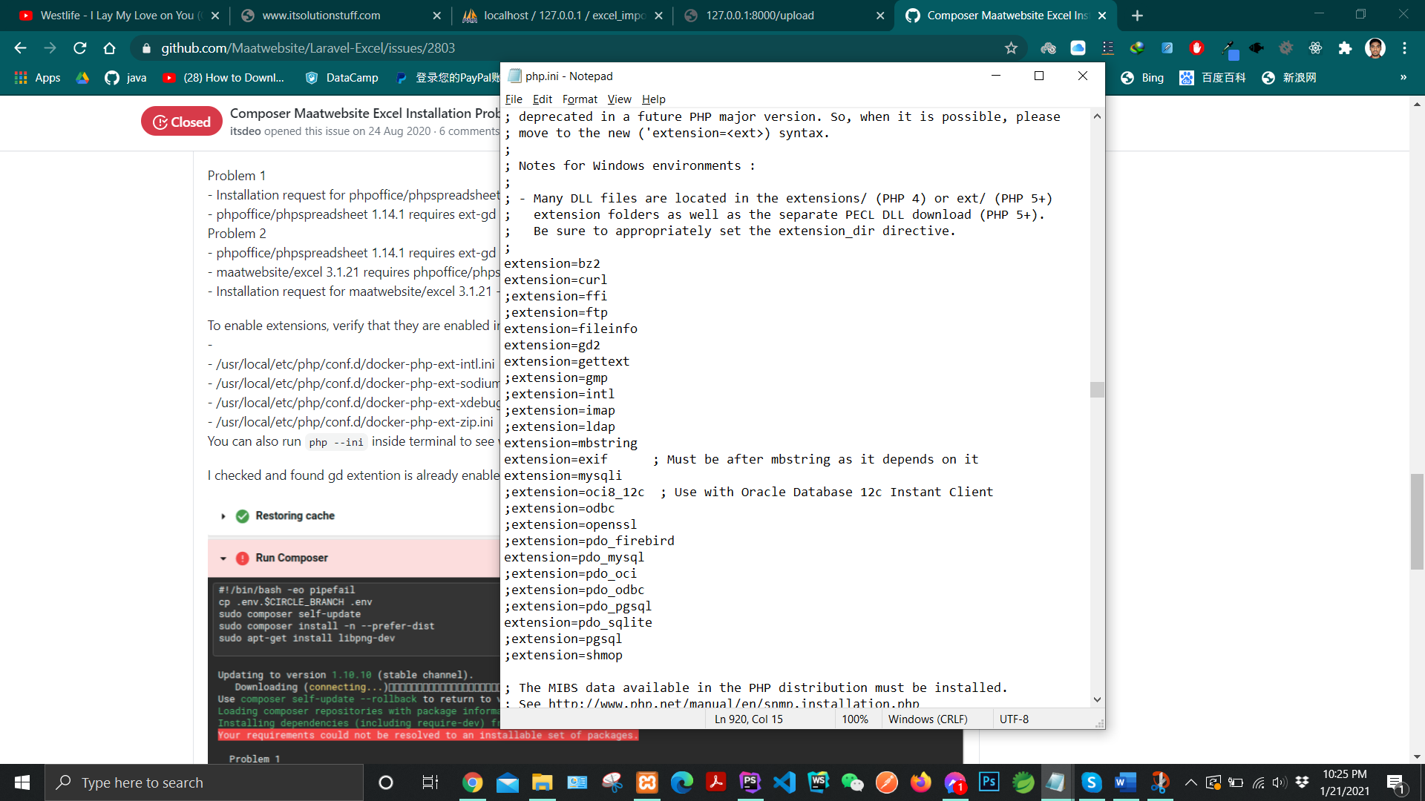

Enable extension containing gd

1. Add those classes on config/app.php

'providers' => [

Maatwebsite\Excel\ExcelServiceProvider::class,

]

and

'aliases' => [

'Excel' => Maatwebsite\Excel\Facades\Excel::class,

]

1. To publish the config, run the vendor publish command:

>> php artisan vendor:publish --provider="Maatwebsite\Excel\ExcelServiceProvider" --tag=config

1. Create a blade file to import an excel sheet

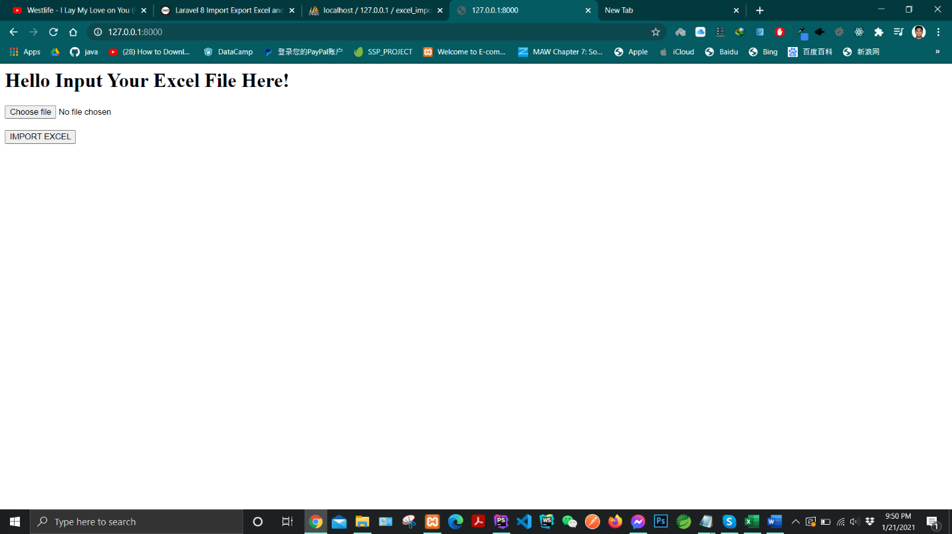

Like this.

1. Create a route to post this form

Route::**post**(**'/upload'**,[UploadController::**class**,**'upload'**]);

1. Create Import Class

>> php artisan make:import ExcelImport

**public function** collection(Collection $collection)  
 {  
*// dd($collection);// Check whether data comes or not* **foreach** ($collection **as** $key=>$value //Simply means $key = number of rows, $value = number of values in each row.  
 **if**($key > 0){  
 $employee = **new** Employee(); //Model object  
 $employee->**name** = $value[0];  
 $employee->**address** = $value[1];  
 $employee->**phone** = $value[2];  
 $employee->**email** = $value[3];  
 $employee->save();// save to the database  
 }  
 }  
 }

Class that we created in step 7

Bring the following changes according to your file.

1. Create a controller:

**public function** upload(Request $request){  
 $file = $request->**file**;  
 Excel::**import**(**new** ExcelImport(),$file); //import class **use** Maatwebsite\Excel\Facades\Excel;

**echo "Successfully Inserted!"**;  
}

1. Create a Model with migration to insert into the database

>> php artisan make:model Employee -m

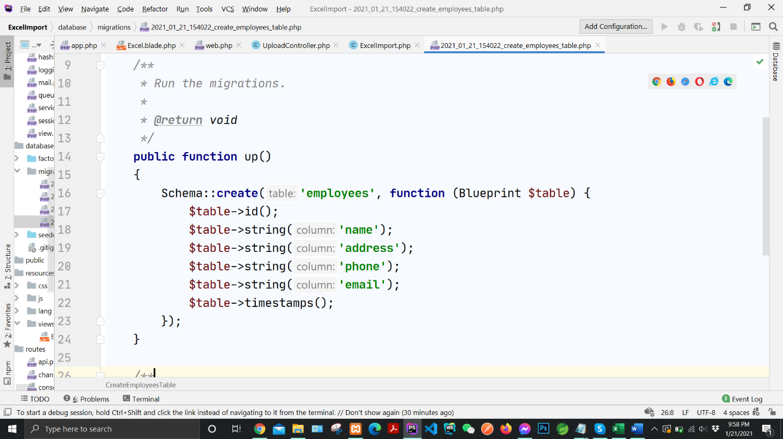

Define the corresponding table columns.

Run the migration

9. Now you’re good to go!

Run the application. Input an excel file and hit submit.

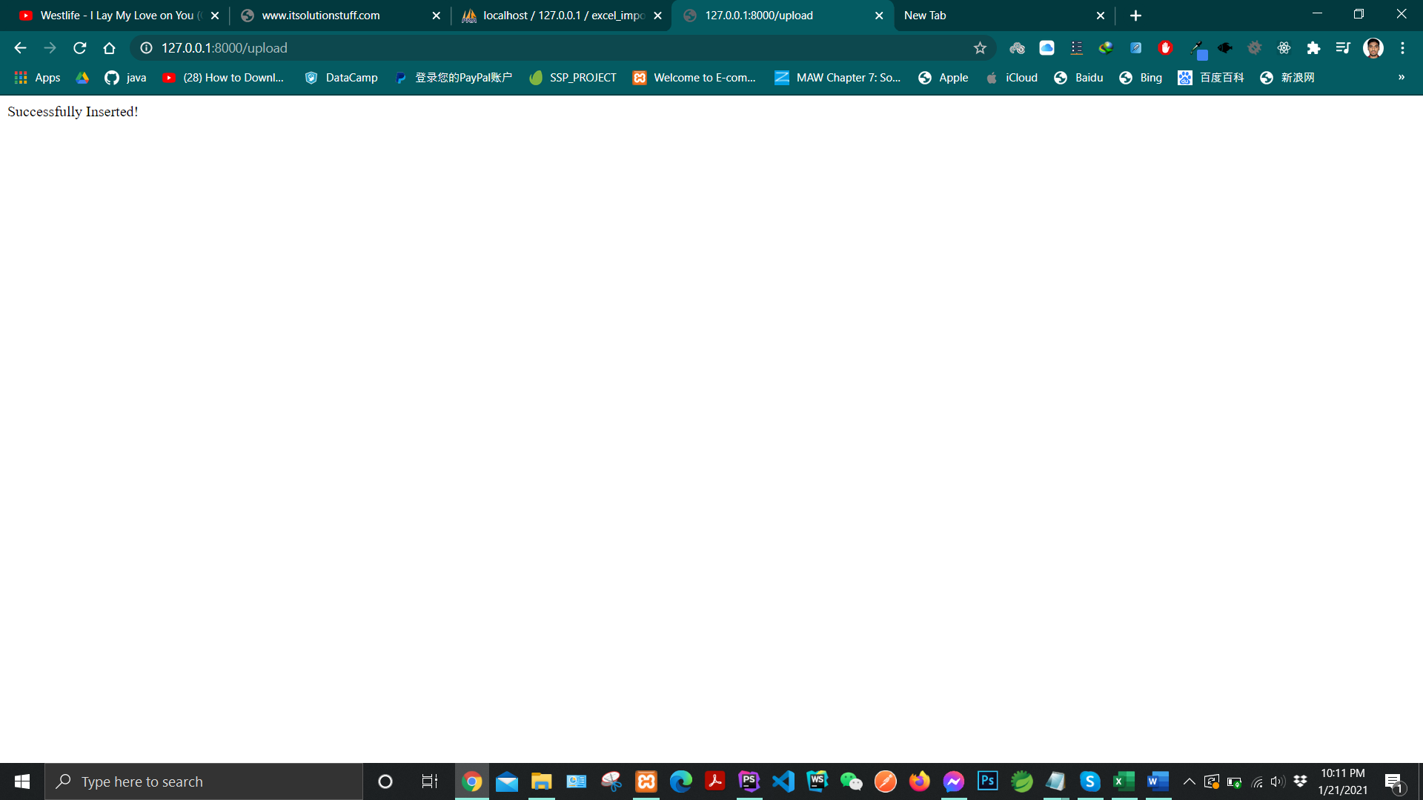

The data has successfully inserted.

Now let’s take a look at the database.

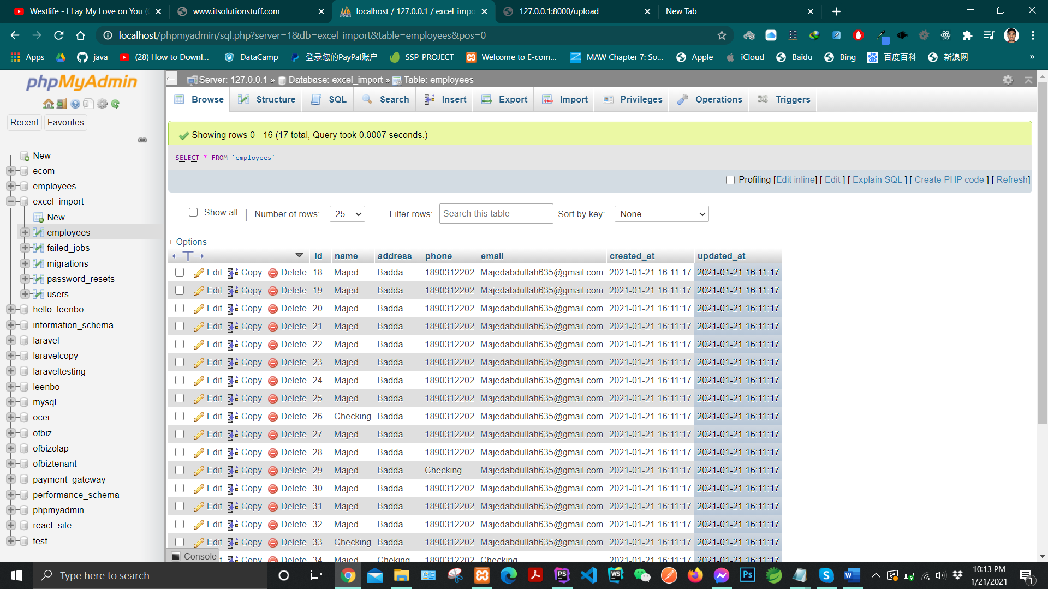

There you go 😉..